# Email Verification

**Step 1: Go to models/user.php**



**Step 2: Go to .env**

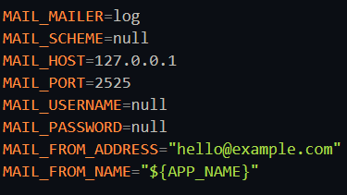

**Step 3: Implement ‘verified’ middleware in routes to apply verification based routing**



**also check by code:**

**$request->user()->hasValidateEmail()**

**Step 4: Manual Verification Go inside storage/logs/laravel.logs**

Clear log file

Register

Check log file for verification link

Paste it on browser to verify

**Step 5: Email Verification with Gmail SMTP**

Go to gmail

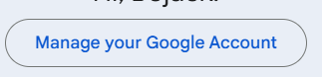

Enable 2 step verification first

Then go to

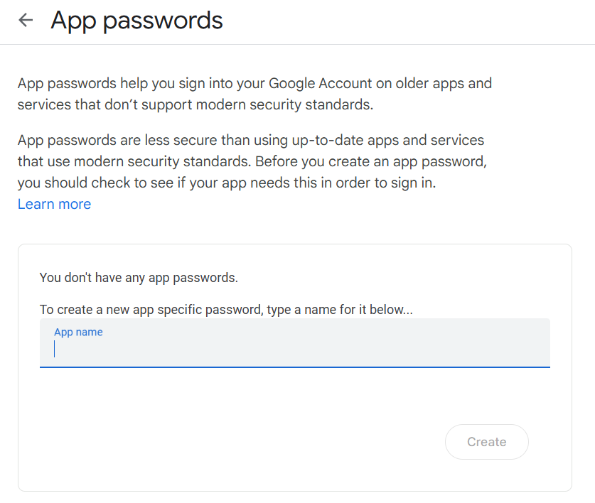

give app name and get password **xomb csxy nsse xgf**

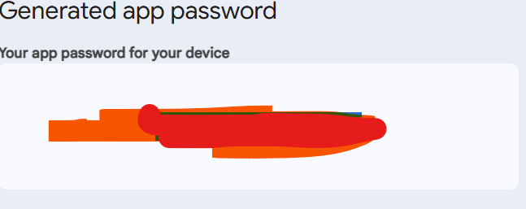

**Step 6: Go to .env**

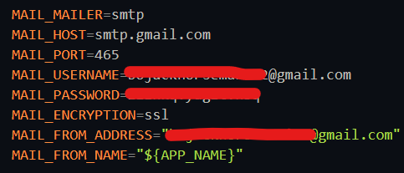

**Step 7: go to terminal**

